TITLE OF THE EXTENDED ABSTRACT
Author Name ^{1*}, Author Name ² & Last Name ²
(1) Department of Civil Engineering, University of Calabria (Italy)
*email: name.surname@unical.it

KEY POINTS

- Two to four key points must be entered.
- Use this style to write the key points.
- The key points should highlight the most innovative aspects of the research conducted.

INSTRUCTIONS
The extended abstract should have a minimum length of 2 pages and a maximum length of 3 pages. It should be written in English. Each page can contain a maximum of one figure (each figure can have several images). Accepted extended abstract will flow into a digital volume of the Conference Proceedings. Accepted extended abstract should be submitted, without including page numbering, in PDF format and it should be associated within a single session to facilitate the process of reviewing it. Style, font, interline, and dimensions are the same of this section.
The sections of the abstract can be organized as follows:
- Abstract
- Introduction
- Materials and methods
- Results and Discussion
- Conclusion
Acknowledgements (if any)
Funding (if any)
References

The section should have one number, and the text should be in capital letters (e.g. INTRODUCTION) while the subsection should have two or more numbers (e.g. 3.1 Case study)

CITATIONS
The following are some examples of citations: “as described in Kellagher et al. (2015)” when the authors are more than two or “as described in Kellagher and Smith (2015)” when the authors are two or “as described in Kellagher (2015)” when there is one author to cite. If it is not necessary to include the author's name within the text, another way to cite is: “several experiments have been conducted in literature (Kellagher et al., 2015)”. If multiple works published are to be cited in the same sentence, the citations should be in chronological order with the years separated by semi-colon as follows: “several experiments have been conducted in literature (Kellagher et al., 2015; Smith et al., 2018)”

FIGURES
The figures should have high quality. This example shows how to insert figures and captions into the text.
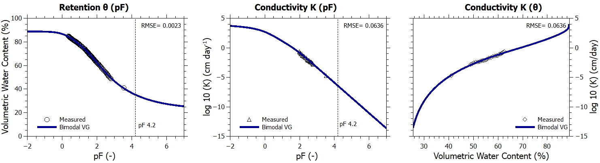
Figure 1. SWRC and UHCC of the investigated soil.
TABLES and EQUATIONS
This example shows how to insert tables and captions into the text
Test | i [mm min⁻¹] | duration [min] | h [mm] | dry time [min]
Test 1 | 2.0 | 15 | 20 | 20
Test 2 | 2.0 | 15 | 20 | 20
Test 3 | 2.0 | 15 | 20 | 20
Table 1. Set up of tests 1, 2, and 3 (i: rain intensity; duration: rain duration; h: cumulated rain depth; dry time between the end of the simulated rain event and the end of the measurement acquisition).
Equations can be written using the Word Equation Editor with reference number on the right, in round brackets
$A=πr^{2}$(1)

BIBLOGRAPHY
This example shows how to insert bibliography into the text

Kumar, S. and Singh, K. K. (2023) Hydrological performance of rain gardens having Calendula officinalis plant with varied planting mixtures . Water Science and Technology, 87(5), 1316–1326.
Kutílek, M. (2004) “Soil hydraulic properties as related to soil structure” in Soil and Tillage Research., 175–184.
Leopold, L. (1968) Hydrology for Urban Land Planning - A Guidebook on the Hydrologic Effects of Urban Land Use. Geological Survey Circular, 554, 1–21. [online] http://enviro.lclark.edu/resources/Tryon/Water/Hydrology.pdf.

